TMA Safe KB Library
  - Setup and practical help for your local password vault
Use these guides to create a vault, organise passwords, adjust locking and recover safely from common errors. The app stores an encrypted file on your device; it has no cloud account or password reset.
TMA-Safe project branch
TMApps Master KB Library: publication has not been verified. This child library is ready for registration when the master index is available.
TMApps main repository

Guide index
Safe-KB1 Create and unlock a vault
Safe-KB2 Organise and update passwords
Safe-KB3 Settings locking and portable backups
Safe-KB4 Troubleshooting and safe support

Before you begin
Use a unique master passphrase and keep an encrypted backup. Store a separate key file away from the vault. Real vaults, key files, browser exports and pairing codes must never be attached to support reports.
Core vault operations work offline. Browser filling also requires a locally installed companion extension and approval in the unlocked app. GitHub help pages and application downloads require connectivity. No online breach monitoring is enabled.

Safe-KB1 Create and unlock a vault
Back to index
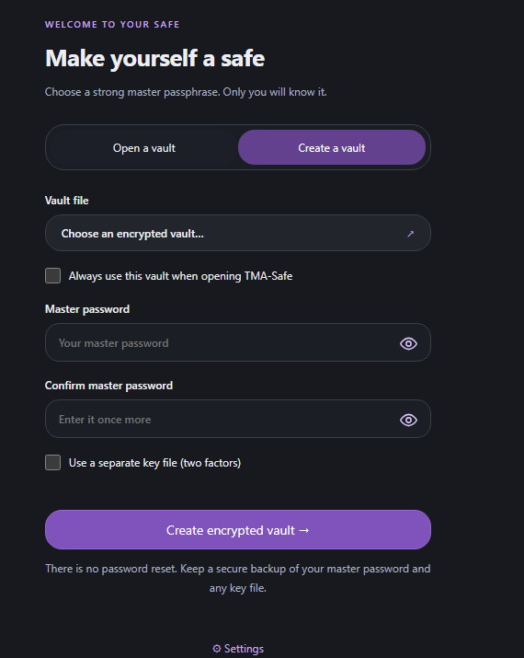
Create a vault with a strong master passphrase and an optional separate key file.
Choose Create a vault, choose a new .tmasafe filename, and enter and confirm a unique master passphrase of at least 14 characters. There is no password reset.
For an additional possession factor, select Use a separate key file and generate a .tmakey file. Keep it separate from the vault. Both the master password and original key file are needed on another computer. TOTP and Windows Hello are not implemented.
Always use this vault remembers only the filename on this device. The master password is required at every launch. After locking, choose your key file again when one is required.
If the saved drive is missing, choose the moved vault again. See Safe-KB4 for unlock errors. This feature works offline.

Safe-KB2 Organise and update passwords
Back to index
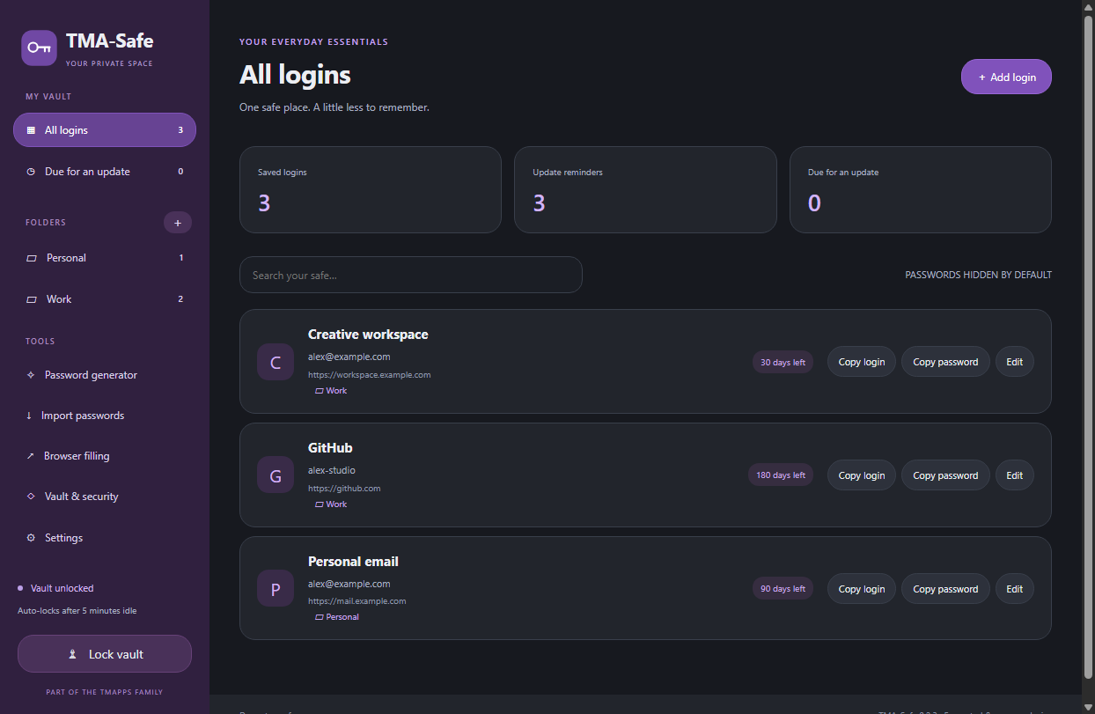
A fictional example vault showing folders and password update reminders.
Use Add login to save a title, HTTPS website, username and password. Use the eye to reveal a password briefly; it hides after 15 seconds, on leaving the window, or on locking. Generate a password with selected length and character groups.
Create folders with the plus beside Folders. Choose a folder in the login editor to move a login. Deleting a folder preserves its logins in All logins.
Set an update reminder in the editor. Due for an update lists expired reminders. Editing notes does not restart a reminder; changing the password does. The app does not change website passwords for you.
Import passwords accepts browser CSV exports. Review valid and skipped rows before importing. CSVs contain plaintext passwords; remove them afterwards and check cloud/recycle-bin copies. Imports, folders and reminders work offline. See Safe-KB3 for locking and backups.

Safe-KB3 Settings locking and portable backups
Back to index
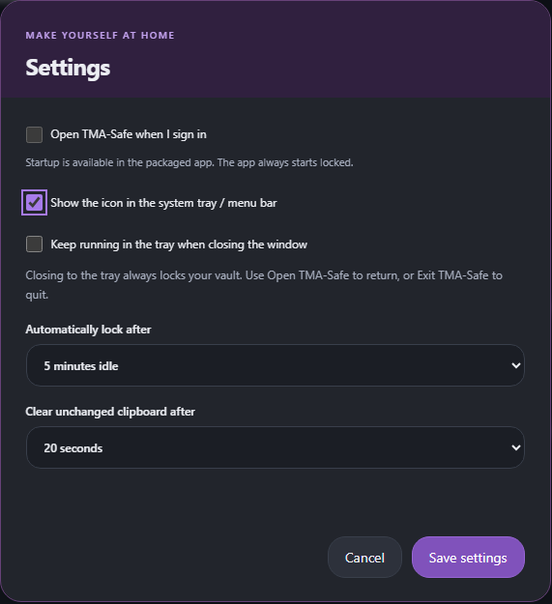
Settings controls for startup, tray behaviour, automatic locking and the clipboard.
Settings is available while locked or unlocked. Startup opens a locked app. Close to tray requires Show tray and locks immediately. Tray availability depends on the desktop environment.
Idle lock defaults to five minutes. Clipboard text clears after twenty seconds if unchanged; clipboard history or third-party managers may retain it. Shorter limits reduce exposure.
Use Vault & security then Save an encrypted portable copy. Copy or move a locked .tmasafe file to another device and open it using the same passphrase and any key file. Copies do not synchronise.
Each save retains an encrypted .bak of the previous version. Keep backups safe because they retain older passwords. Unlocking uses about 128 MiB for scrypt, briefly increasing CPU/RAM usage; it is deliberate password-guessing resistance. This app has no cloud service or paid integration.

Safe-KB4 Troubleshooting and safe support
Back to index
Could not unlock: check the master password, original key file and selected vault. Try a known encrypted backup copy. There is no password reset; never upload a vault, key or CSV to obtain help.
Operation cancelled because the vault locked: an operation was interrupted by locking. Unlock again and repeat it. Closing the editor or leaving the window also cancels a delayed password reveal.
Vault changed on disk: another writer or sync tool changed the file. Lock and reopen before editing. Preserve both copies and compare manually; avoid simultaneous edits to cloud-synchronised copies.
Vault is being saved elsewhere, or a stale .lock file needs review: close other app instances and confirm no save is running. Back up the vault before removing an abandoned lock file.
Expected a regular file within the size limit: choose a normal vault/import file or the original 32-byte key file. Files that grow past the limit or nonregular paths are rejected.
Browser filling unavailable: unlock, enable filling, pair the companion extension, and visit the exact HTTPS origin of the saved login. Every fill requires native approval. Filling contacts only the local loopback bridge; opening support links or downloading updates requires internet access.
If an error persists, report the app version, OS, steps and a sanitised error through GitHub Issues. Review the report and remove private account names and paths. Security vulnerabilities belong in private reporting, not a public issue.
The app is an unsigned beta without an independent audit. AES-256-GCM protects vault data at rest; the provider has no account, recovery key or remote vault access. A compromised computer can capture unlocked data. No dark-web/breach lookup or passkey provider is implemented. See Safe-KB1 for recovery precautions.

